Labman Database EER description(Milestone 1)

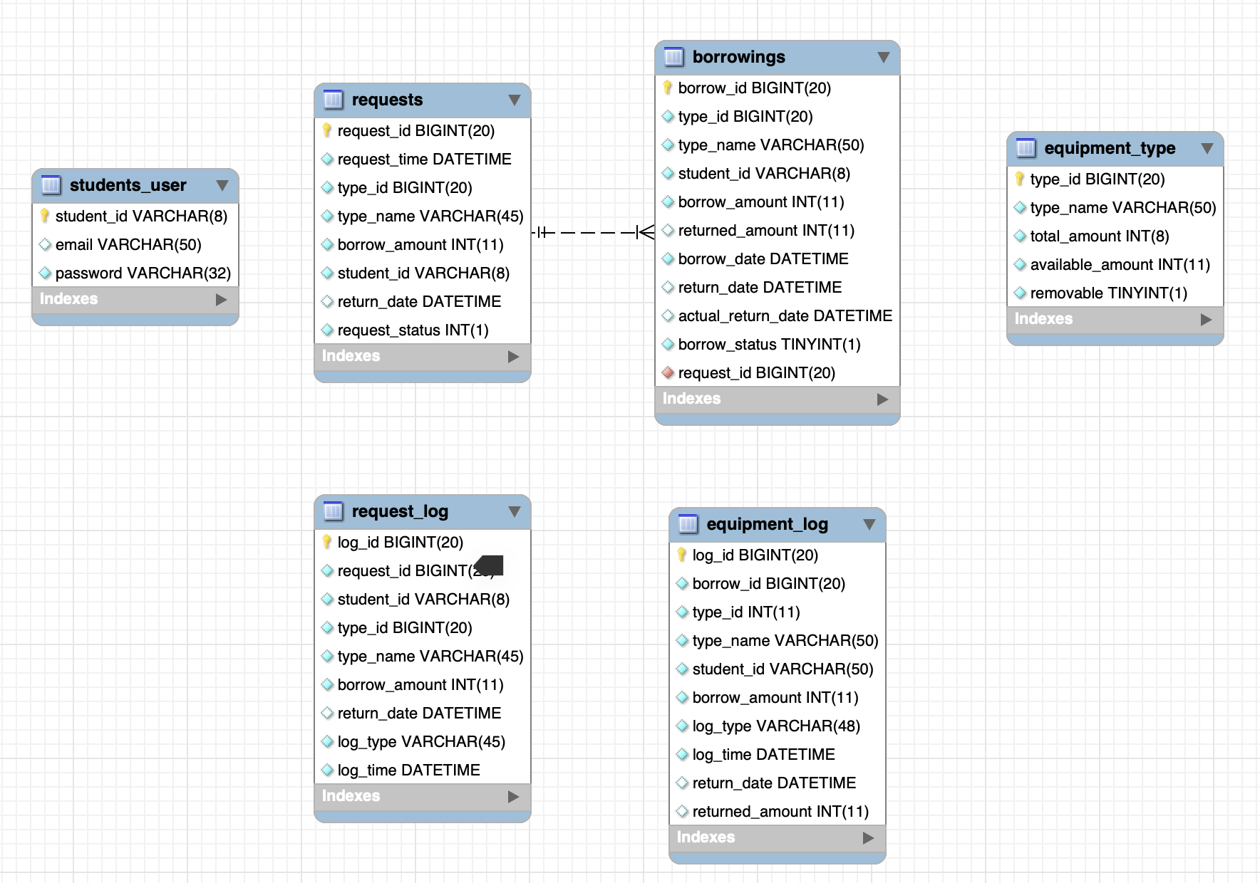

Tables and fields

Student table

* student_id (primary,string): The unique identifier of the UoA student.
* email (string): The email address of student, default is UoA email address’ studentID@adelaide.edu.au’.
* password (string): The student unique password to log in account

Requests table

* request_id (integer, primary key): The unique identifier of request.
* request_time(datetime): Time the request is received by server
* type_id (int): The unique identifier of equipment.
* type_name(string): The name of equipment.
* borrow_amount(int): The number of equipments user requested.
* student_id(string): The name of user account.
* return_date: The due date to return the equipment
* Request_status:
* 0:pending
* 1:collected
* 2:cancelled

Request log Table

* log_id (integer, primary key): The unique identifier of request log.
* request_id (integer, foreign key): The unique identifier of request.
* student_id (string): The name of the user account.
* type_id (integer): The unique identifier of the equipment.
* type_name (string): The name of the equipment.
* borrow_amount (int): The number of equipment user request.
* log_type (int): There are four types of status for request log, from 0 - 3
* 0 - create request : The request for initialization.
* 1 - pick request : The request to pick equipment.
* 2 - edit request : The request to edit the equipment log
* 3 - cancel request : The request for cancel booking.
* log_time (datetime): The time create or modified log.

Borrowings table

* borrow_id (integer, primary key): The unique identifier of the borrowing record.
* type_id (integer, foreign key): The unique identifier of the equipment.
* type_name (string): The name of the equipment.
* student_id (string): The name of the user account.
* borrow_amout (integer): The quantity of this borrowing.
* borrow_date (datetime): The date and time when the equipment was borrowed.
* return_date (datetime): The due date of the return.
* actual_return_date (datetime): The date when the equipment was actually returned.
* borrow_status (TINYINT - integer): The status of the borrowing.
  + 0:unreturned
  + 1: returned
* request_id (integer, foreign key): The unique identifier of request.

Equipment Log table

* log_id (integer, primary key): The unique identifier of the equipment log.
* borrow_id (integer, foreign key): The unique identifier of the borrowing record.
* type_id (integer): The unique ID of the equipment.
* type_name(string): the name of the equipment.
* user_id (integer): The ID of the user who borrowed or returned the equipment.
* student_id(string): the student id.
* borrow_amout (integer): The quantity of this borrowing.
* log_type (int): There are three types of equipment logs, from 0 - 2 including

0 - borrow : the equipment has borrowed out

1- return : the equipment has return back

2 - cancel return : cancel the equipment return process, the further operation could be borrow.

* log_time (datetime): The time of created or modified log.

Equipment table

* type_id (integer, primary key): The unique identifier of the equipment.
* type_name (string): The name of the equipment.
* total_amout (integer): The total quantities of this equipment.
* available_amount (integer): The quantities of this equipment available.
* removable(boolean): 0 not removable; 1 removable.